**IFT 466 Advanced Computer Networks**

**Lab 3  
EIGRP – Passive Interface**

After you complete each step, put a ‘√’ or ‘x’ in the completed box

**Quick Reminder:** Passive interface command is used to control the advertisement of routing information. The command enables the suppression of routing updates over some interfaces while it allows updates to be exchanged over the other interfaces.

1. Setup up the following topology on Packet Tracer

✓

1. Configure IP addresses on the R0 interfaces

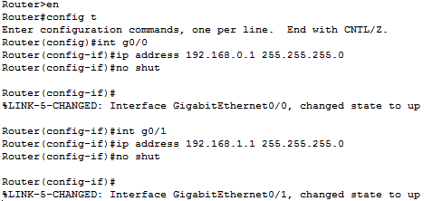

✓

1. **Logo

   Description automatically generated with low confidence**Repeat the same configurations for Routers 1 and 2 using the addresses on the topology above.   
     
    ✓
2. Now we will configure EIGRP on the routers starting on R2

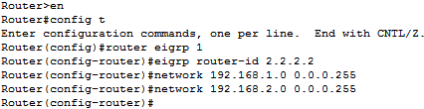

✓

1. Repeat the same steps for Routers 0 and 1

✓

1. Go back into Router 2  
     
   Now run the show ip eigrp neighbors command, you should see both neighbors.  
     
   Insert a screenshot of the command below with both neighbors shown

1. Now run the show ip protocols commands verify that EIGRP 1 is the protocol  
     
   Check out the metrics being used….K1 and K3 should both be usedGraphical user interface, text, application

   Description automatically generated

✓

1. Now run the show ip route on Router 2 to make sure that the 192.168.0.0 network is in our route table (which was learned via EIGRP).  
     
   Insert a screenshot of the command below with both neighbors shown

1. Go back to R2 and we will make the G0/0 interface passive



✓

1. Insert a screenshot of the message which appears telling you that you connection to the neighbor is “down” as the hold time has expired.

1. Now run the show ip eigrp neighbors command on R2 and that neighbor should not appear on the list.   
     
   Insert a screenshot of the command below with that neighbor gone.

